MONGODB ASSIGNMENT 3
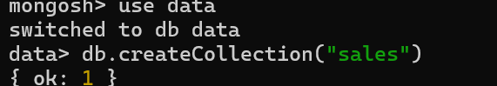
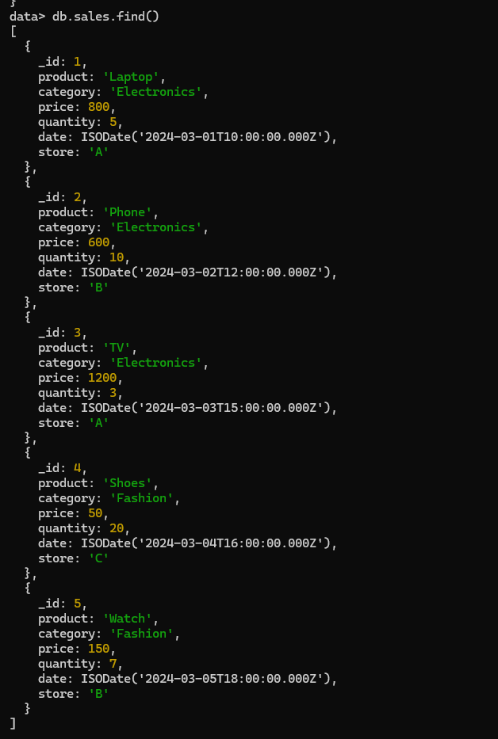

1 Total sales per product.
db.sales.aggregate([{$group:{_id: ”$product”,totalSales:{$sum:{multiply:[“price”,”quantity”]}}}}])

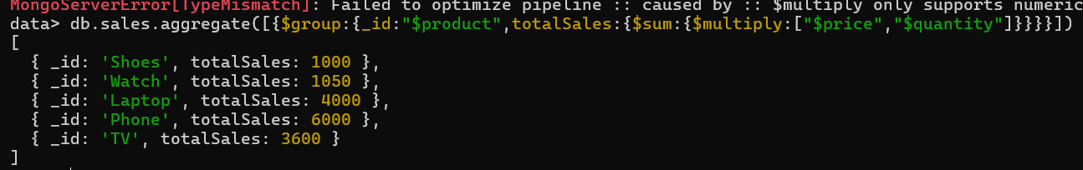

2 Total revenue per product this do sum of all products
db.sales.aggregate([{$group:{_id:"product",totalRevenue:{$sum:{$multiply:["$price","$quantity"]}}}}])

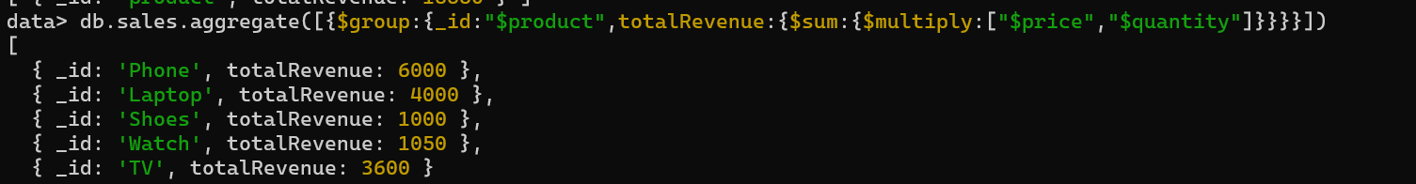

3 Total revenue per category.
db.sales.aggregate([{$group:{_id:"$category",totalRevenue:{$sum:{$multiply:["$price","$quantity"]}}}}])

4 Count of products per category.
db.sales.aggregate([{$group:{_id:"$category",count:{$sum:1}}}])

5 Store-wise total sales.
db.sales.aggregate([{$group:{_id:"$store",totalSales:{$sum:{$multiply:["$price","$quantity"]}}}}])
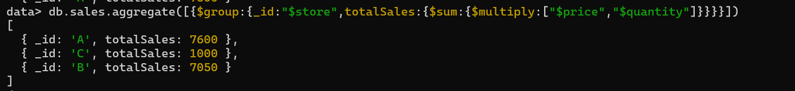
6 Average price of products per category.

db.sales.aggregate([{$group:{_id:"$category",avgPrice:{$avg:"$price"}}}])
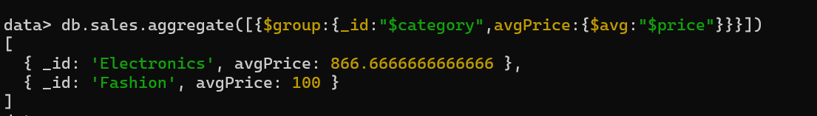

7 Top-selling product.

db.sales.aggregate([{$group:{_id:"$product",totalSales:{$sum:"$quantity"}}},{$sort:{totalSales:-1}},{$limit:1}])

8 Total sales for Electronics category.
db.sales.aggregate([{$match:{category:"Electronics"}},{$group:{_id:"Electronics",totalSales:{$sum:{$multiply:["$price","$quantity"]}}}}])
9 Sales trend over time (day-wise total sales).
db.sales.aggregate([{$group: {_id: { $DateToString: { format: "%Y-%M-%D", date: "$date" } },totalsales: { $sum: { $multiply: ["$price", "$quantity"]}}}])
10 Highest revenue-generating product.
db.sales.aggregate([{$group:{_id:"$product",totalRevenue:{$sum:{$multiply:["$price","$quantity"]}}}},{$sort:{totalRevenue:-1}},{$limit:1}])
11 Average revenue per sale.

db.sales.aggregate([{$project:{sales:{$multiply:[“$price”,”$quantity”]}}},{$group:{_id:”category”,avgSales:{$avg:”sales”}}}])

12 Sales performance per store.
db.sales.aggregate([ { $group: { _id: "$store", totalsales: { $sum: { $multiply: ["$price", "$quantity"] } } } }] )
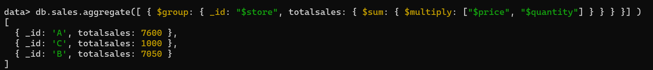
13 Products sold more than 5 times.
db.sales.aggregate([{$group: {_id: "$product",totalSales: { $sum: "$quantity" }}},{$match: { totalSales: { $gt: 5 } }}])

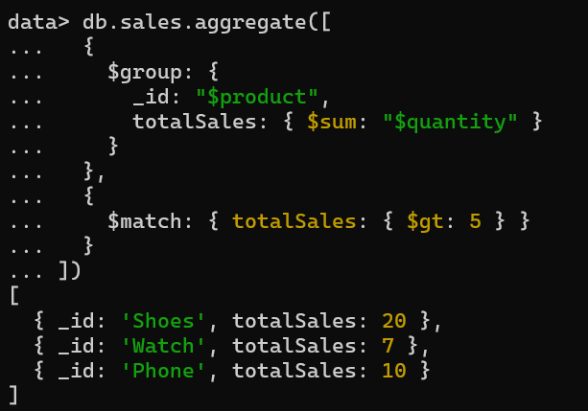
14 Least sold product.
db.sales.aggregate([{$group: {_id: "$product",totalSales: { $sum: "$quantity" }}},{$sort: { totalSales: 1 }},{$limit: 1}])

15 Monthly sales summary.
db.sales.aggregate([{$group: {_id: { $dateToString: { format: "%Y-%m", date: "$date" } },totalSales: { $sum:{ $multiply: ["$price", "$quantity"] } }}}])

16 Number of unique products sold.
db.sales.aggregate([{$group: {_id: "product",uniqueProducts: { $addToSet: "$product" }}},{$project: {uniqueProducts: { $size: "$uniqueProducts" }}}])

17 Maximum and minimum priced product
db.sales.aggregate([{$group: {_id: "price",maxPrice: { $max: "$price" },minPrice: { $min: "$price" }}}])

18 Total revenue per product in descending order.
db.sales.aggregate([{$group: {_id: "$product",totalRevenue: { $sum: { $multiply: ["$price", "$quantity"] } }}},{$sort: { totalRevenue: -1 }}])

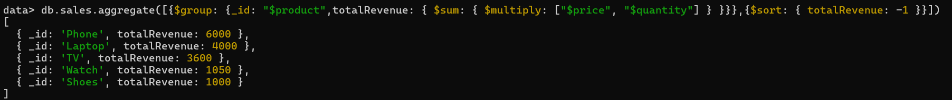
19 Revenue generated per store per category.
db.sales.aggregate([{$group: {_id: { store: "$store", category: "$category" },totalRevenue: { $sum: { $multiply: ["$price", "$quantity"] } }}}])

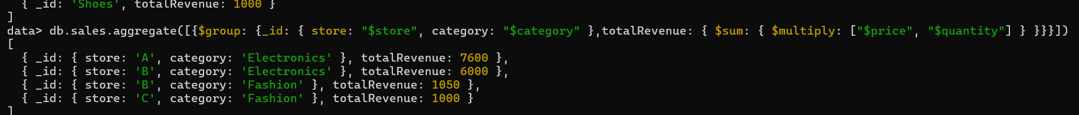

20 Products contributing more than 50% revenue.
db.sales.aggregate([{$group: {_id: "$product",productRevenue: { $sum: { $multiply: ["$price", "$quantity"] } }}},{$group: {_id: null,totalRevenue: { $sum: "$productRevenue" },products: { $push: "$$ROOT" } // Keep all products in an array}},{$unwind: "$products"},{$match: {"products.productRevenue": { $gt: { $multiply: ["$totalRevenue", 0.5] }}}}])
